Take Notes: C++ for Financial Mathematics
- Accompanying website https://johnarmstrongmaths.com/cppbook/cpp-website.html
- Developing on Mac https://johnarmstrongmaths.com/cppbook/mac.html

To learn more and get OneNote, visit www.onenote.com.

Chap 1: Getting started
- C++ is a compiled language – Unlike python, Java or other which are interpreted language
- Compile because CPU (central processing Unit) speaks only assembly (different computer might use different assembly language) so need to translate in specific language. This operation is called compilation
- In “compiled” language, the instructions are converted to machine code before the program ever run. Supposed to be faster than interpreted language but with machine speed now, this advantage is debatable (or not relevant anymore)
- Major disadvantage is that you must recompile if you change the type of machine you want to run it on
- Just in time compiler @JIST https://en.wikipedia.org/wiki/Just-in-time_compilation (improve speed of compilation) Compilation during execution of a program rather than before execution
- Debug executable executable that contains not just machine code but also information about how machine code corresponds to the original source code the added information will make the program bigger and slower but very helpful for debugging
- To remove the original source code info for speed create a release executable without all the debugging information (check the properties)
- As well as compilation errors, code can contain programming errors that the compiler does not spot
- When debugging, you should treat the error messages as the compiler’s best guess of what you’ve got wrong. In particular, the line number might be slightly below the actual line containing the error or even a different line
- grossProfit is an example of camel case – the reason is because the word has now got a hump like a camel

Chap 2: Basic Data Types and Operators
- Whenever you use a variable in C++, you must specify the type of data you will store in that variable. Moreover, you can’t change the type later C++ is a statically called language
- Because data is stored on computers using 1s and 0s, it is natural to store integers using binary digits
- A single binary digit is called a bit (contraction of binary digit)
- 8 (2^3) binary digits (bit) are called a byte (pronounced b-ai-te)
- 1024 (2^10) bytes makes a kilobytes
- 1048576 (2^20) bytes makes up a megabyte
- Numbers representing memory locations are often written in hexadecimal (base 16, with 0, 1, 2, …, A = 10, B= 11, … F = 16)
- 4 binary digits are equivalent to one hexadecimal digit called a nibble
- DANGER: When you divide two integers in C++ you get another integer, 3/5 = 0 (automatic rounding if necessary)
- On top of data type key words (e.g. int, double, float, …), we can specify range of possible values using the data-type specifiers key words (e.g. short, long, long long, unsigned, unsigned long long, …)
- Value of -2^31 to 2^31 – 1 in a int variable, -2^63 to 2^63-1 in q long long variable but the exact value depends of the C++ compilers
- Unsigned variable can be twice as big as signed ones because no bit assigns for the sign
- DANGER: if you add 1 to a maximum possible value for the integer, C++ wraps to the value round so that it takes now the minimum value in practice, C++ do the operation in binary and discard the top binary digit if an integer overflows the possible range
- size_t is used to store the size of the data structure stored in memory
- Summary for integer: For integer used mainly int or long – don’t bother with the other
- Summary for floating point number: use double, float or long double to store real numbers. Note that 1 is an integer while 1.0 is a real number in C++
- When comparing two real numbers, you should never use equality as most real number will be approximated so prefer delta with a buffer
- Special double to know: -Inf, Inf, NaN, -0.0
- Summary for booleans: use bool keyword and you can print that using cout << operator
- Summary for characters: use char to define a variable intended to store character as a number between 0 and 255 (00 to FF in hexadecimal) taking exactly 1byte in memory.
- Characters is appropriate data type to store a character string written in English which may contain some numbers and punctuation marks. However, using the char data type is inappropriate for serious programs targeted at an international audience
- In C++, Casting is the operation of converting between one data type and another
- Example C-style cast: double aDouble = (double) anInt ;
- Example of C++ style cast: int anInt = static_cast <int> (aDouble) ;
- C-style cast is to be preferred in most case
- Summary for Memory addresses: Commonly known as a pointer. CPU is very good at manipulating memory addresses. However, an experience C++ programmer knows that pointers are only an appropriate tool for solving problems involving direct memory access
- How to think of memory address: a 32-bit computer consist of 2^32 bytes of data stored in memory location. Each memory location is itself labelled with a number (so called memory address aka pointer) from 0 to 2^32-1 (in hexadecimal from 00000000 to FFFFFFFF)
- How to define a pointer variable in C++:
  - double* dPointer = 0x00000000 ;
  - meaning: a pointer to a double or a memory location containing a double
- The one place where beginners are most likely to encounter a pointer is in so-called C-strings:
  - Const char* speech = “To be or not to be?” ;
  - Meaning: this creates a variable speech which is of type const char aka it’s a pointer to a memory location containing a character
  - Meaning: the const in front means that you can’t use the variable speech to change the text
  - The memory location that speech points to contains the first letter of the speech “T” and the next memory location in sequence contains the letter “o” and consecutive char are stored in consecutive memory location
  - Important note: To mark the end of the speech, a character code 0 is automatically used
- Thinking of text in terms of pointers to memory locations is a pretty difficult way to work, better alternative is to use nonnative data type of C++
  - string speech = “To be or not to be?”;
  - but to use that you must #include <string> ; using namespace std;
  - Technically a string is not a basic data type in C++. This is why you must write #include <string>.
- Summary for Operators: Many operators available
  - sizeof,
  - mathematical operations +, *, -, /
  - comparison >, <, >=, =<, ==, !=
  - logical && for and, || for or, ! for not
  - bitwise & (AND), | (OR), ^ (XOR), ~ (inversion), << n (shift all the bits in a n to the left) and >> (shift all the bits in a n to the right)
  - combining you must follow the precedence of some operators, BODMAS (bracket, division, multiplication, addition and subtraction)
  - assignment
  - if statement
- Comparison is always with two equals sign (==), one equal (=) is just assignment
- How make the bell sound with C++
  - https://stackoverflow.com/questions/61540065/making-a-beep-with-a-in-c-not-working-in-xcode-on-mac

- Remember how to create and executable with terminal
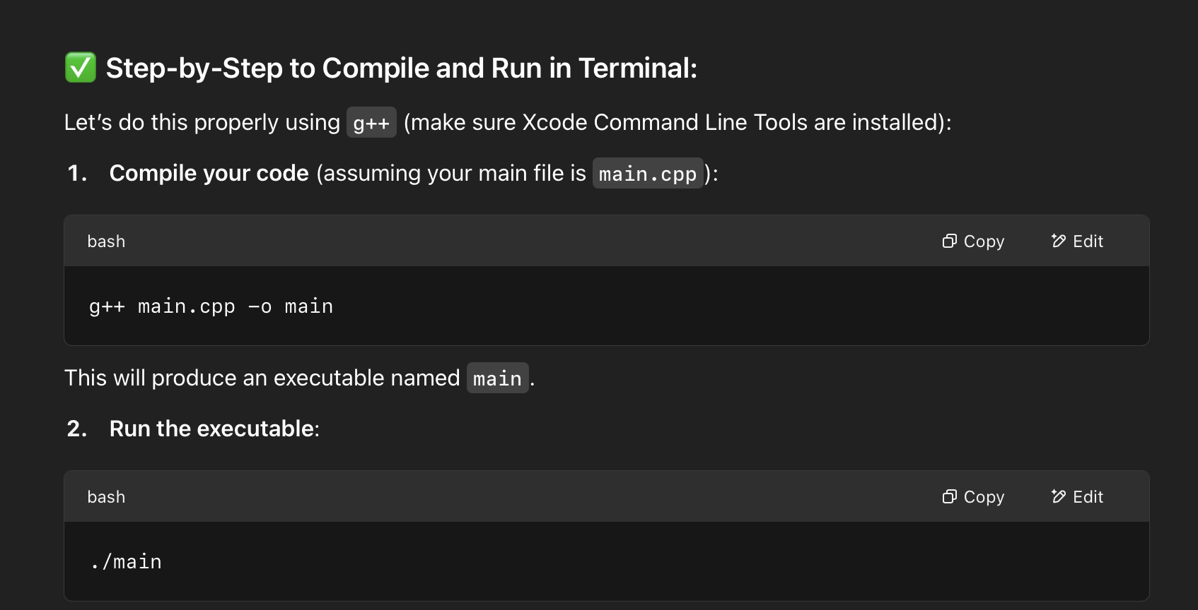

Chap 3: Functions

